**MACHINE LEARNING WITH PYTHON**

A Project Report Submitted to the Bharathidasan University in partial

fulfillment of requirement for the award of the degree of

**BACHELOR OF COMPUTER SCIENCE**

Under the guidance of

**Dr. K. ELANGOVAN, M.Sc., M.Phil., Ph.D**

Guest Lecturer



**DEPARTMENT OF COMPUTER SCIENCE**

**GOVERNMENT ARTS AND SCIENCE COLLEGE (Co-Ed),**

(Affiliated to Barathidasan University)

**THARAGAMPATTI-621 311.**

**APRIL -2023**

PROJECT REPORT

**Early Prediction for Chronic Kidney Disease Detection: A Progressive Approach to Health Management**

**Team Leader** - Pradeep R

**Team Member**  - Sathishkumar P

## Team Member - Muthukrishnan M

## Team Member - Yuvaraj S

**INTRODUCTION**

Chronic Kidney Disease also called Chronic Kidney Failure, describes the gradual loss of Kidney Function. It occurs slowly over many years. The Kidneys filter wastes and excess fluids form the blood, which are then excreted in the urine and waste can build up in our body.

**OVERVIEW:**

* Chronic Kidney Disease(CKD) means the Kidneys are damaged and can’t filter blood the way they should. The disease called “***CHRONIC***” because the damage to the kidneys happens slowly over a long period of time. CKD can also cause other problems that can harm your health such as **Heart Disease** and **Stroke**
* CKD is defined as either kidney damage of GFR< 60 ml/min for 3 months.
* Kidney Damage
* Pathological abnormalities or markers of damage – includes blood,
* Urine: RBCs, Blood or Protein
* or Imaging (e.g.: USG showing renal abnormalities)

**Stages of CKD:**

**EARLY STAGES OF CKD:**

1. CKD in its early stages typically does not present any symptoms. This is due to the large decrease in the function of kidneys.
2. It is common for kidney disease to not be diagnosed until this stage unless a routine test for another issue, such as a test of the blood or urine, discovers a potential problem.
3. If it is discovered at an early stage, treatment with medication and ongoing monitoring with routine tests may help prevent it from progressing to a more advanced state.

**CKD IN ITS ADVANCED STAGES:**

1. If Kidney disease isn’t caught early or keeps getting worse even after treatment, there may be a number of signs.
2. Kidney failure is the last stage of CKD. It is also called end-stage renal disease or established renal failure.
3. It is possible that ***dialysis*** or a ***kidney transplant*** will be needed at some point.

**Normal Increased Damage GFR Kidney failure CKD Death**

**risk**

**DIALYSIS:**

* The objectives of Heamodialysis are to extract toxic nitrogenous substances from the blood and to remove excess water.
* In Peritoneal Dialysis, a thin tube inserted in the abdomen

fills the abdominal cavity with a dialysis solution that absorbs waste and excess fluids.

* After a period of time, the dialysis solution drains from the body, carrying the waste with it.

**KIDNEY TRANSPLANT:**

* Kidney Transplantation or renal transplantation is the organ transplant of a kidney into a patient who has end-stage renal disease.
* Transplanted kidneys can come from deceased or living donors.

|  |  |  |
| --- | --- | --- |
| **5 STAGES OF CHRONIC KIDNEY**  **DISEASE** | | |
|  | **Kidney Function/**  **GFR** | **Description** |
| **STAGE 1** | **>90%** | **Normal or High**  **Function** |
| **STAGE 2** | **60 – 80%** | **Middle Decreased**  **Function** |
| **STAGE 3** | **30 – 90%** | **Mild or Moderately**  **Decreased Function** |
| **STAGE 4** | **15 – 19%** | **Severely Decreased**  **Function** |
| **STAGE 5** | **< 15%** | **Kidney failure** |

**PURPOSE OF CKD:**

* The Kidney Damage occurs slowly over many years. Many

People don’t have any symptoms until their kidney disease is very advanced.

* Blood and Urine Test are the only two ways to know if you have kidney disease

**Transplant Coordination**

**Treatment Options Education**

**Advanced Care Planning**

**Medications & Adherence Review**

**Dietary Counselling**

**Dialysis Access Placement**

Patient with Progressive CKD

* Treatments cannot cure kidney disease, but they may slow kidney disease. They include medicines to lower blood pressure, control blood sugar, and lower cholesterol.
* CKD may still get worse over time. Sometimes it can lead to a kidney failure. If your kidneys fail, you will need Dialysis or a Kidney Transplantation.
* They also keep the body’s chemicals balanced, help control blood pressure, and make hormones.

**You can take steps to keep your kidneys healthier longer:**

1. Choose foods with less salt.
2. Control your blood pressure; your health care provider can tell you what your blood pressure should be.
3. Limit the amount of alcohol you drink.
4. Keep your blood sugar in the target range, if you have diabetes
5. Loss weight if you are overweight
6. Be physically active
7. Don’t Smoke
8. Choose foods that are healthy for your heart: fruits, vegetables, whole grains, and low-fat dairy foods.

**EMPATHY MAP:**

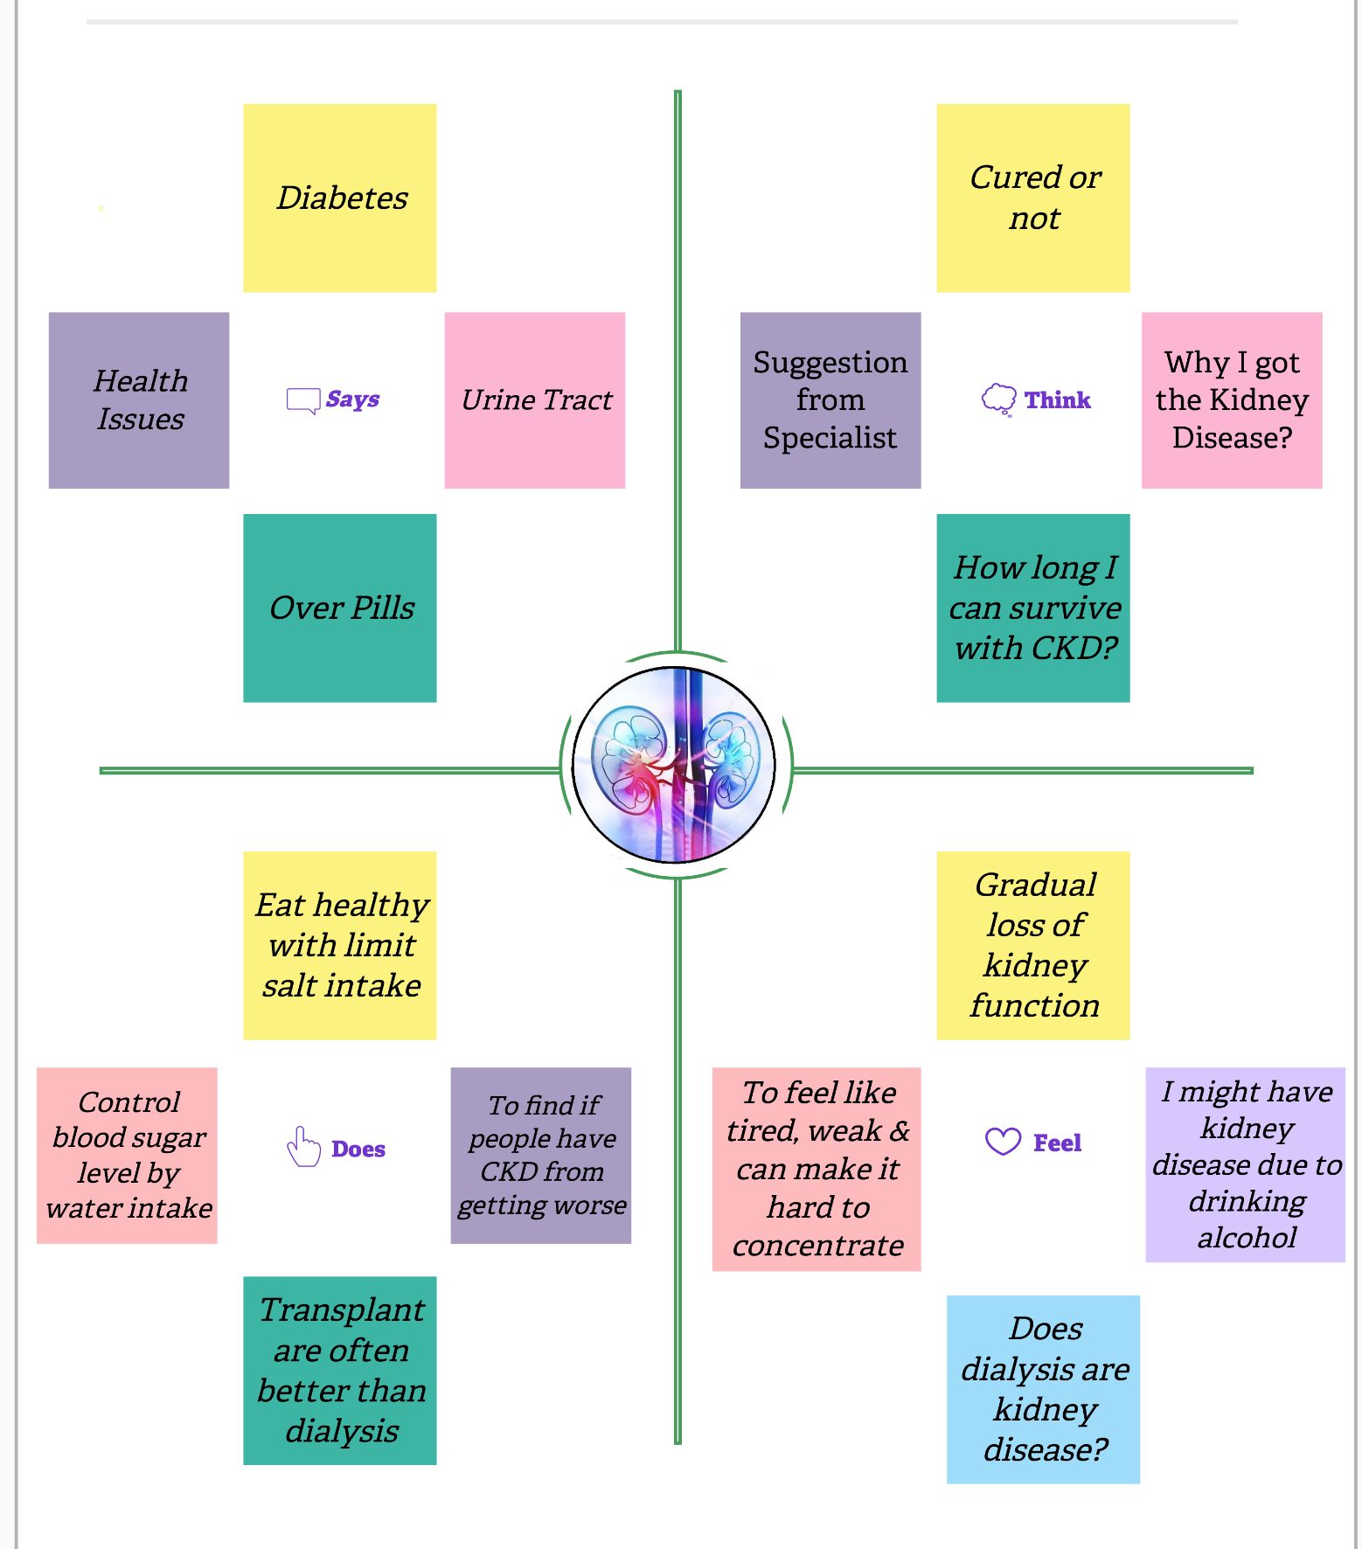

**BRAINSTORMING AND IDEATION:**

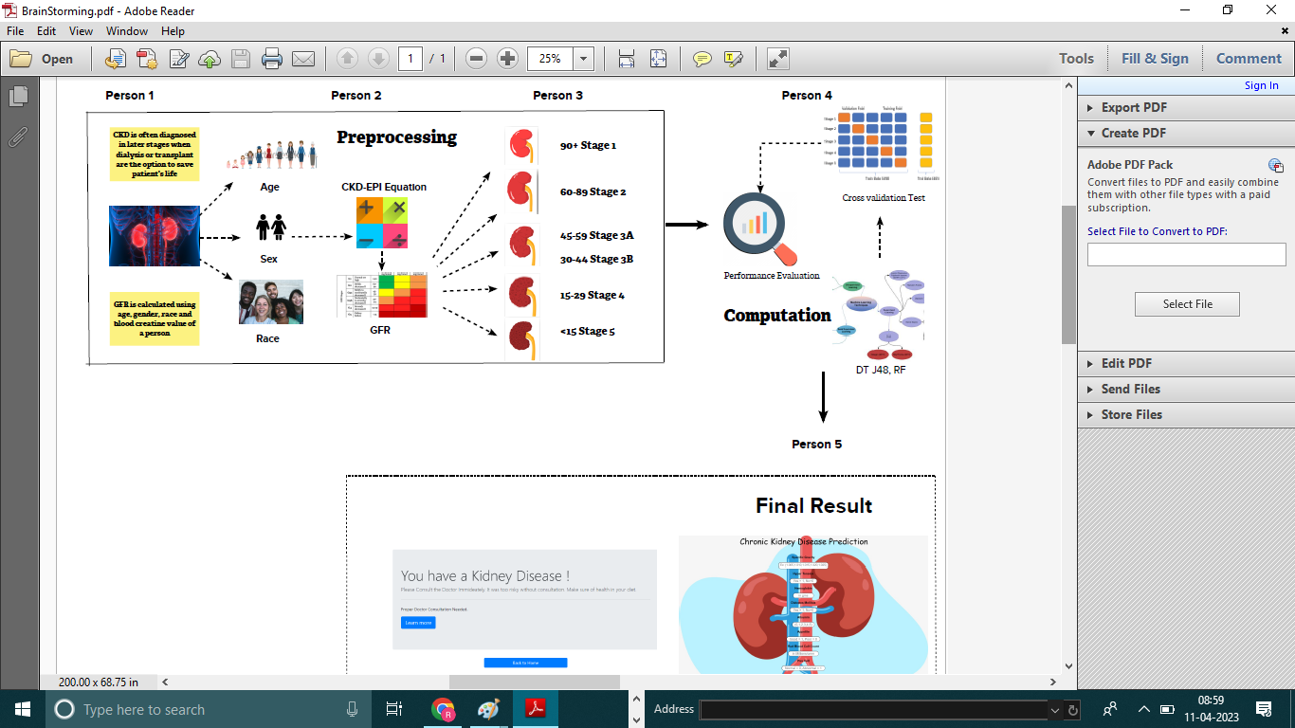

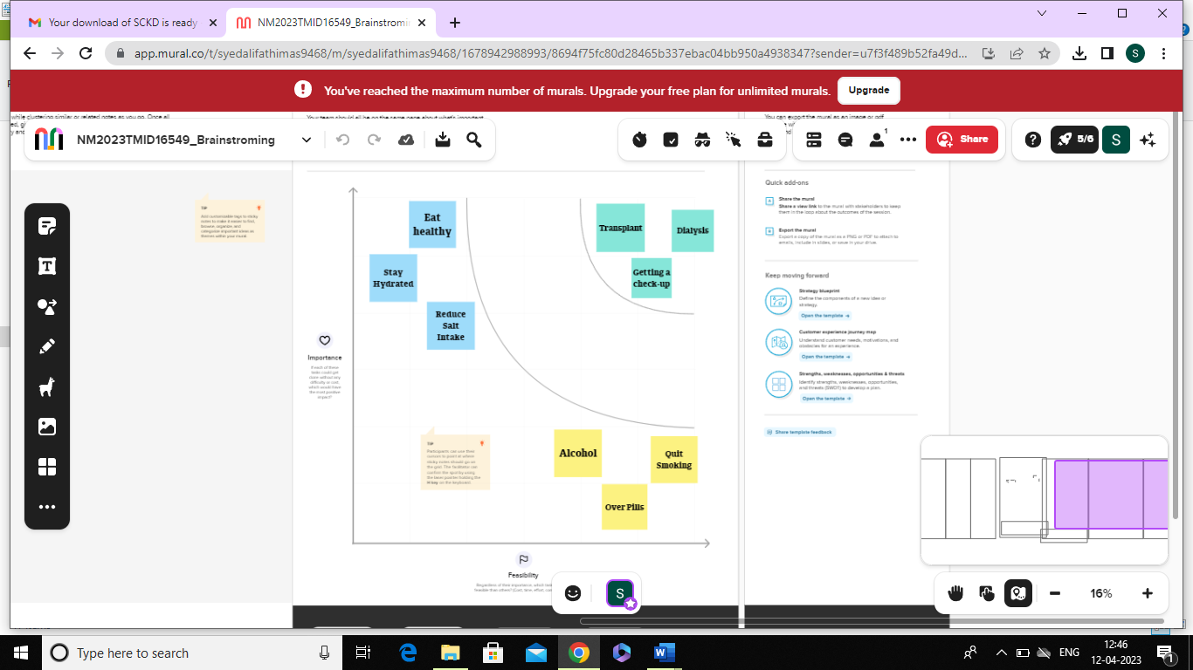

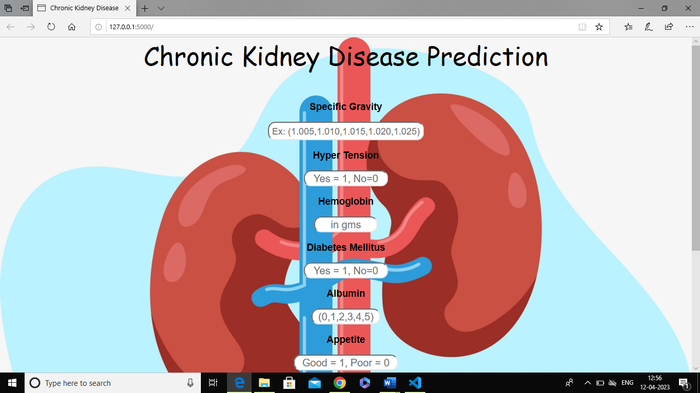

**RESULT**:

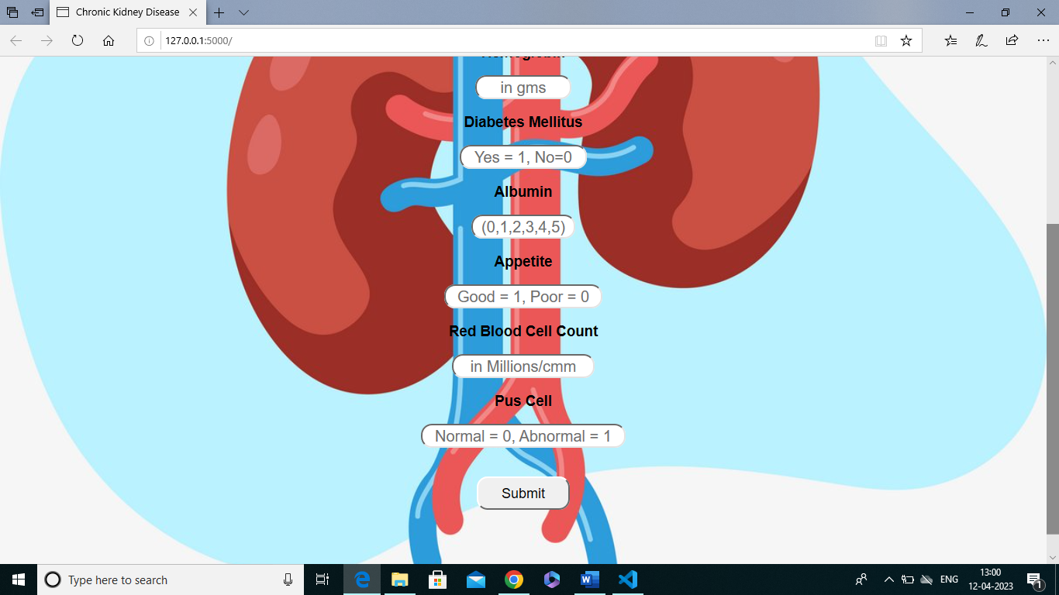

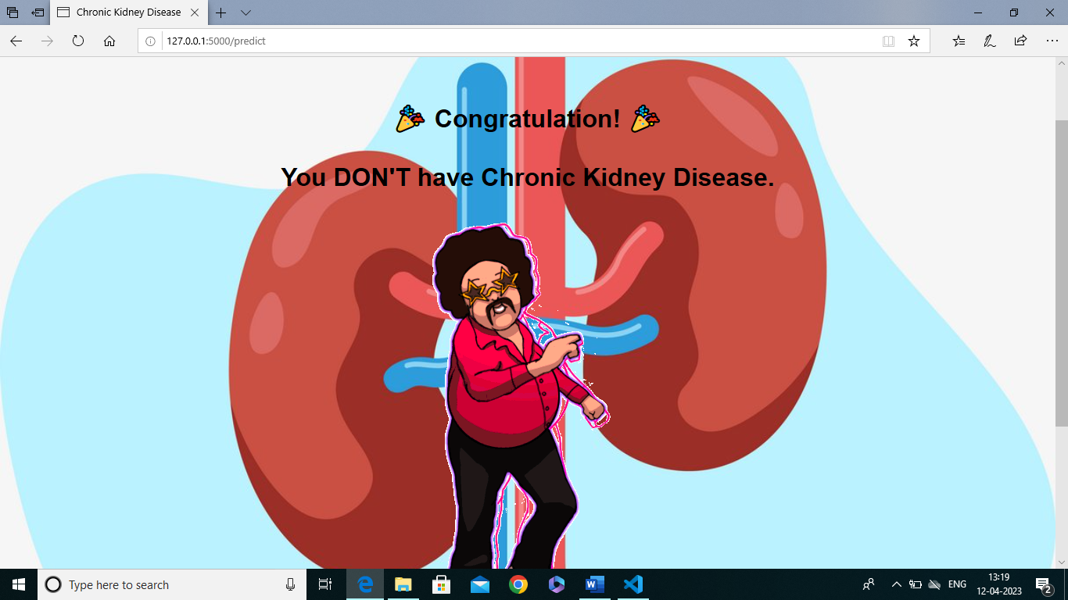

**PROS AND CONS OF CKD:**

**ADVANTAGES OF CKD:**

* No need for Anticoagulation Treatment.
* Reduced risk of hypertension.
* Drainage of ascitic fluid.
* Continuous depuration of infections.
* Early diagnosis of infections.
* Caloric input of Glucose.

**Kidney Transplant:**

* Patients can lead a more normal life without having to watch what they eat and drink.

**Dialysis:**

* Available to all kidney patients.

**DISADVATAGES OF CKD:**

* Protein loss through dialysate.
* Increased risk of peritonitis(?).
* Incapacity due to limited manual skills.

**Kidney Transplant:**

* Shortage of organ donors.
* Kidney only lasts 8-9 years on average.

**Dialysis:**

* Patients must limit their salt and protein intake between dialysis sessions.
* Regular Dialysis sessions- impact on the patient’s lifestyle.

**APPLICATIONS AREAS:**

Nearly 99 per cent of peoples affected by the kidney disease. The Overall prevalence of CKD in the general population is approximately 14 per cent. High Blood Pressure and Diabetes are the main cause of CKD. Almost Half of individuals with CKD also have diabetes and/or self-reported cardiovascular disease (CVD). More than Americans have kidney failure.

**CONCLUSIONS:**

* By early detection, treatment increasing community outreach, and access to preventive medicine for high-risk population, can decrease the rising burden of CKD.
* It is important to recognize CKD as a risk factor for CVD.
* hronic Kidney Disease is a worldwide killer that is under-diagnosis and under treated.
* The models that are constructed using CKD patients are then trained and validated using the input parameters.
* Symptoms can be very different and depend on the primary disease and stage of chronic renal failure.
* The consequence is complex according to the different function of the kidney and involve many organ systems.
* The increased burden of CKD in developing countries is due to globalization, low socioeconomic status, and poor access to health care and health care disparities.
* The underlying mechanisms for endocrine disturbances are complex and include modification in feedback mechanisms, abnormal hormone production and transport, and altered hormone metabolism and elimination.

**FUTURE SCOPE:**

* Kidney Disease aims to provide a platform the communication of novel research findings from clinical science, basic and translational research on the entire spectrum of nephrological and urological disorders.
* The increasing global prevalence of Chronic Kidney Disease and end stage renal disease with the associated spiraling cost has profound public health and economics implications.
* High Blood Pressure Medications: People with kidney disease may experience worsening high blood pressure. It can initially decrease kidney functions and charge electrolyte levels.
* Take medications as instructed, ask your doctor about blood pressure medicines called angiotensin-converting enzyme inhibitors and angiotensin II receptor blockers, which may protect your kidneys in addition to lowering blood pressure.
* Include a Kidney Doctor (nephrologist) on your health care team.

**APPENDIX**:

SOURCE CODE:

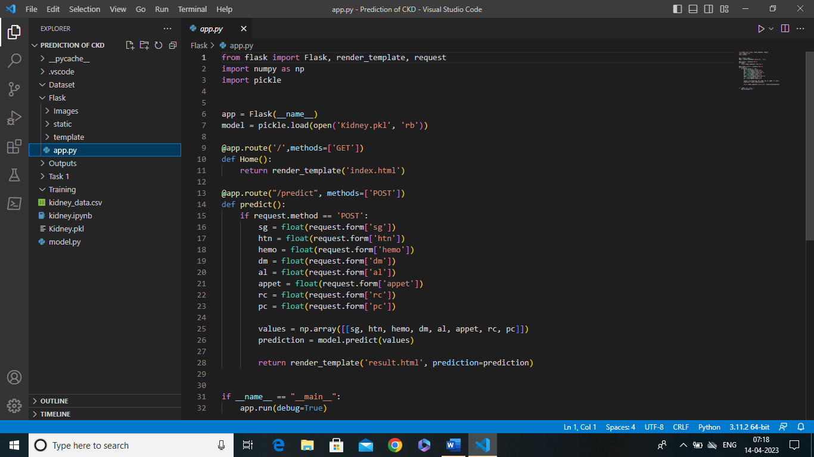

**THANK YOU!!!**